**WEEK 4**

**Spring Rest**

**Exercise: Hello World RESTful Web Service:**

**CODE:**

**HelloController.java:**

package com.cognizant.spring_learn;

import org.slf4j.Logger;

import org.slf4j.LoggerFactory;

import org.springframework.web.bind.annotation.GetMapping;

import org.springframework.web.bind.annotation.RestController;

@RestController

public class HelloController {

    private static final Logger LOGGER = LoggerFactory.getLogger(HelloController.class);

    @GetMapping("/hello")

    public String sayHello() {

        LOGGER.info("START: sayHello()");

        String message = "Hello World!!";

        LOGGER.info("END: sayHello()");

        return message;

    }

}

**SpringLearnApplication.java:**

package com.cognizant.spring_learn;

import org.springframework.boot.SpringApplication;

import org.springframework.boot.autoconfigure.SpringBootApplication;

@SpringBootApplication

public class SpringLearnApplication {

    public static void main(String[] args) {

        SpringApplication.run(SpringLearnApplication.class, args);

    }

}

**application.properties:**

server.port=8083

spring.application.name=spring-learn

logging.level.org.springframework=INFO

logging.level.com.cognizant.spring_learn=DEBUG

**Output:**

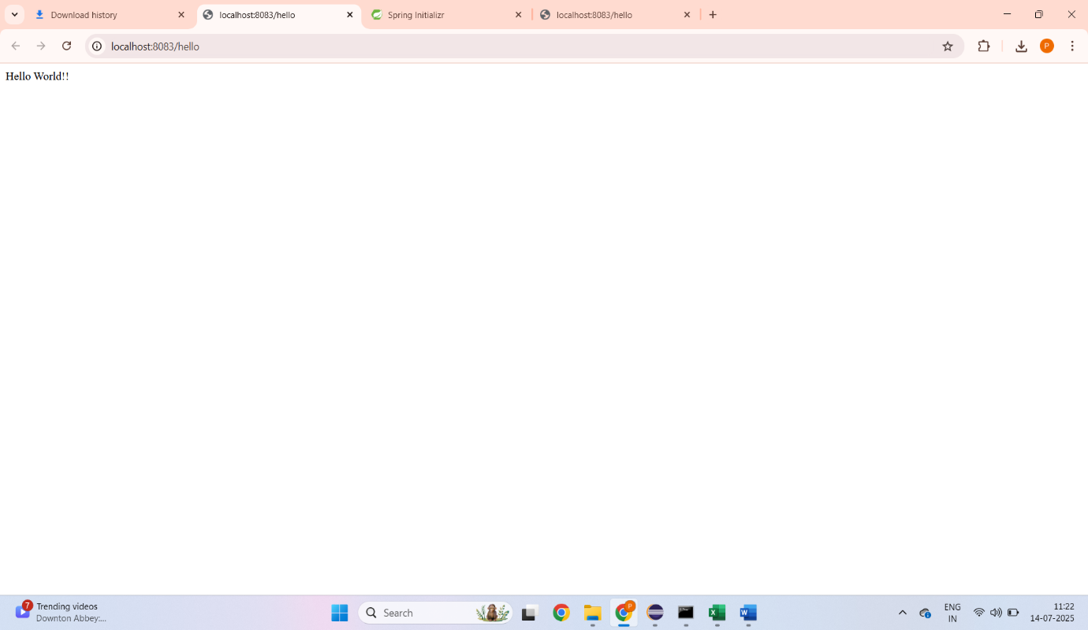

**Exercise: REST - Country Web Service:**

**CODE:**

**Country.java:**

package com.cognizant.spring_learn.model;

public class Country {

    private String code;

    private String name;

    public Country() {}

    public Country(String code, String name) {

        this.code = code;

        this.name = name;

    }

    public String getCode() {

        return code;

    }

    public void setCode(String code) {

        this.code = code;

    }

    public String getName() {

        return name;

    }

    public void setName(String name) {

        this.name = name;

    }

}

**CountryController.java:**

package com.cognizant.spring_learn;

import org.slf4j.Logger;

import org.slf4j.LoggerFactory;

import org.springframework.web.bind.annotation.RequestMapping;

import org.springframework.web.bind.annotation.RestController;

import com.cognizant.spring_learn.model.Country;

import org.springframework.context.ApplicationContext;

import org.springframework.context.support.ClassPathXmlApplicationContext;

@RestController

public class CountryController {

    private static final Logger LOGGER = LoggerFactory.getLogger(CountryController.class);

    // Load the ApplicationContext once when the controller is created

    private final ApplicationContext context;

    public CountryController() {

        LOGGER.debug("Initializing ApplicationContext from country.xml");

        context = new ClassPathXmlApplicationContext("country.xml");

    }

    @RequestMapping("/country")

    public Country getCountryIndia() {

        LOGGER.info("START getCountryIndia");

        Country country = (Country) context.getBean("country");

        LOGGER.info("END getCountryIndia");

        return country;

    }

}

**application.properties:**

server.port=8083

spring.application.name=spring-learn

logging.level.org.springframework=INFO

logging.level.com.cognizant.spring_learn=DEBUG

**country.xml:**

<?xml version="1.0" encoding="UTF-8"?>

<beans xmlns="http://www.springframework.org/schema/beans"

       xmlns:xsi="http://www.w3.org/2001/XMLSchema-instance"

       xsi:schemaLocation="http://www.springframework.org/schema/beans

        https://www.springframework.org/schema/beans/spring-beans.xsd">

    <bean id="country" class="com.cognizant.spring_learn.model.Country">

        <property name="code" value="IN"/>

        <property name="name" value="India"/>

    </bean>

</beans>

**Output:**

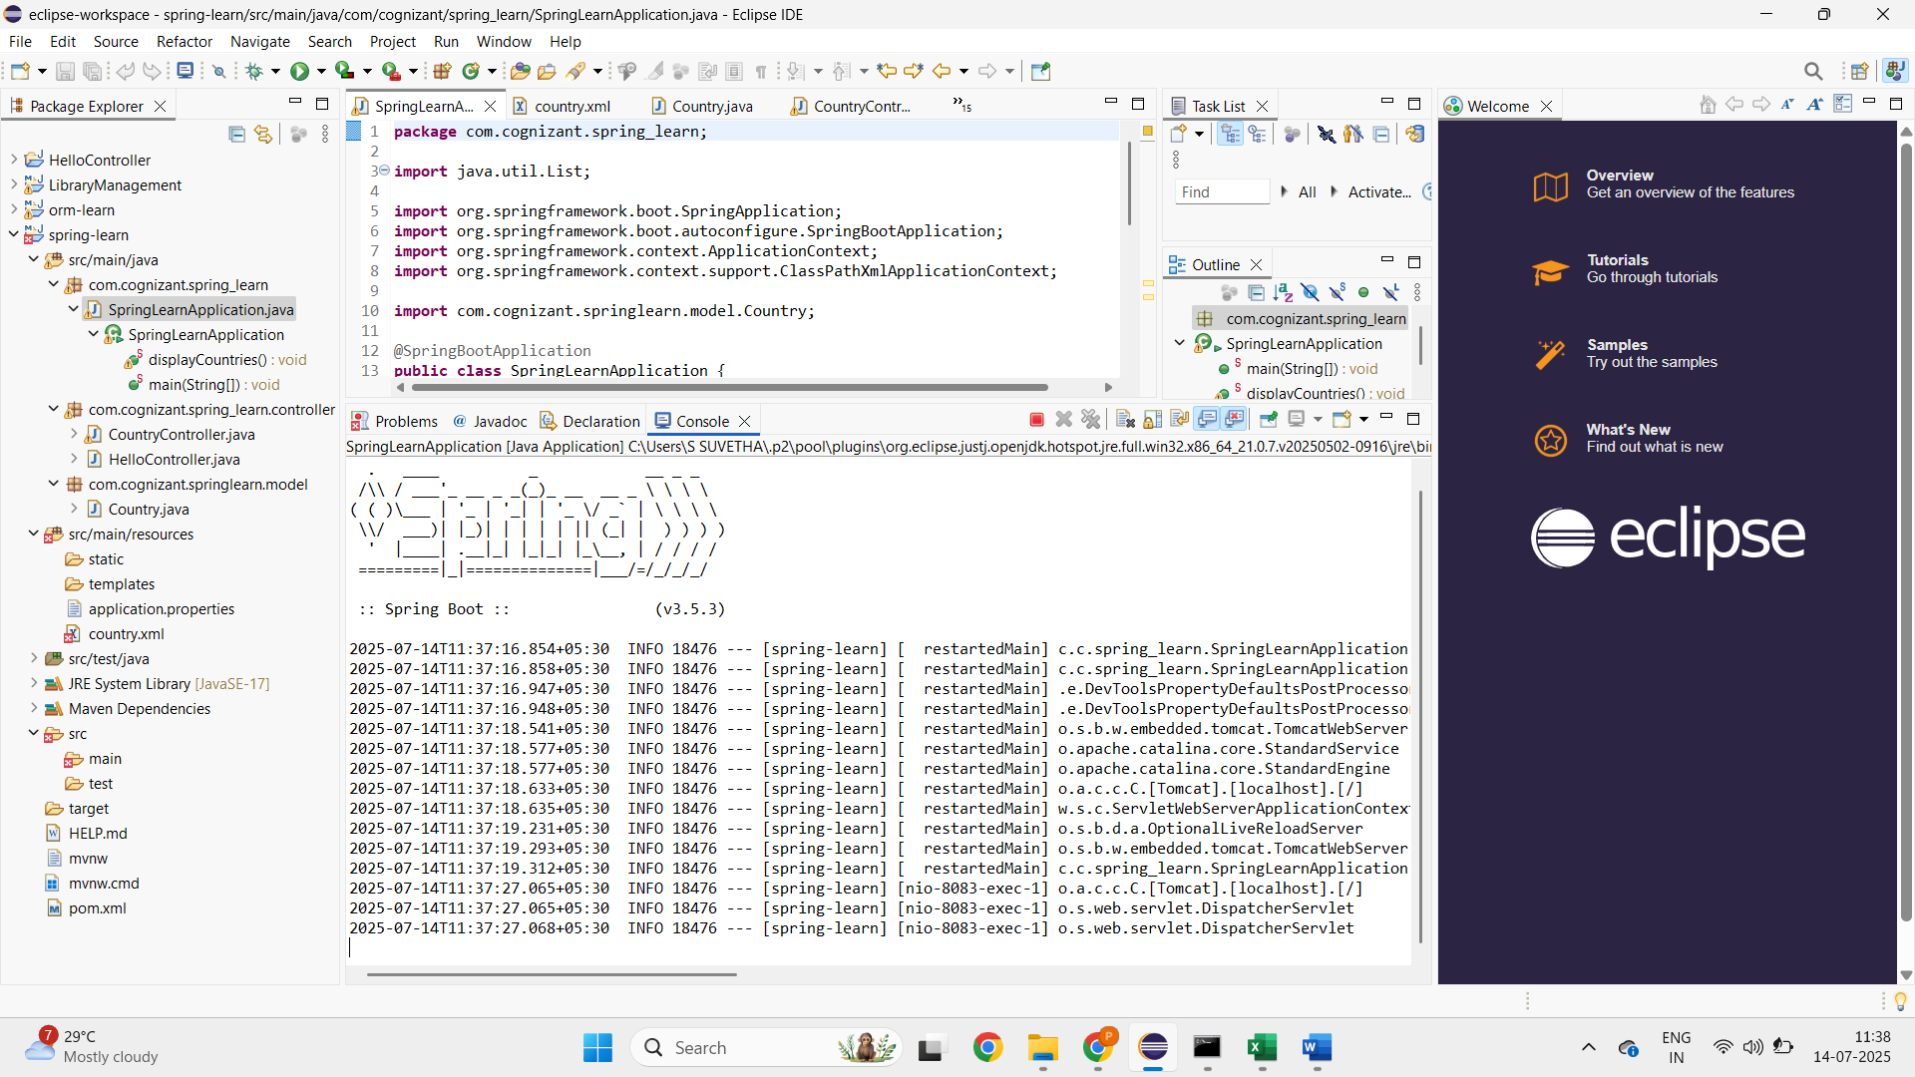

**REST - Get country based on country code   
 Code**

package com.cognizant.spring_learn.service;

import com.cognizant.springlearn.model.Country;

import org.springframework.beans.factory.annotation.Autowired;

import org.springframework.context.ApplicationContext;

import org.springframework.stereotype.Service;

import java.util.List;

@Service

public class CountryService {

@Autowired

private ApplicationContext context;

public Country getCountry(String code) {

List<Country> countryList = (List<Country>) context.getBean("countryList");

return countryList.stream()

.filter(c -> c.getCode().equalsIgnoreCase(code))

.findFirst()

.orElse(null); // Return null or throw exception as needed

}

}

OUTPUT:

